INGLES BASICO Y TECNICO

PAST SIMPLE IRREGULAR VERBS WORKSHEET

Presentado por:

**SANTIAGO CHAPARRO RIAÑO**

Dirigido a:

**ANLLY CAROLINA CORTES CORREA**

CENTRO DE LA INDUSTRIA LAS EMPRESA Y LOS SERVISIOS

NEIVA-HUILA

2024

COMPETENCIA: INGLES

FICHA: 2900177

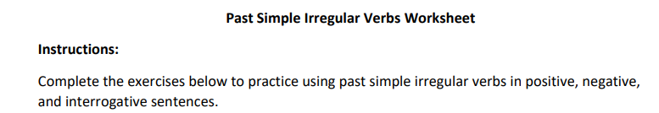

She went (go) to the market yesterday.

They had (have) a great time at the party last night.

He saw (see) his friend at the park.

We took (take) a lot of photos during our trip.

I ate (eat) a delicious meal at the new restaurant.

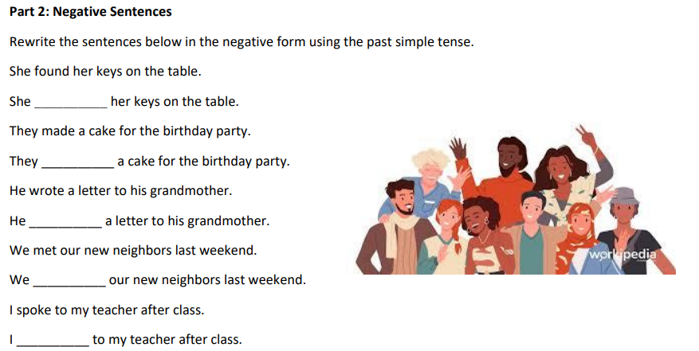

She didn't find her keys on the table.

They didn't make a cake for the birthday party.

He didn't write a letter to his grandmother.

We didn't meet our new neighbors last weekend.

I didn't speak to my teacher after class.

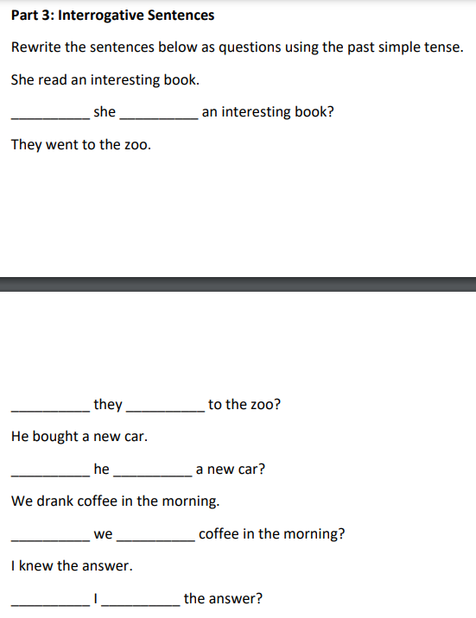

Did she read an interesting book?

Did they go to the zoo?

Did he buy a new car?

Did we drink coffee in the morning?

Did I know the answer?

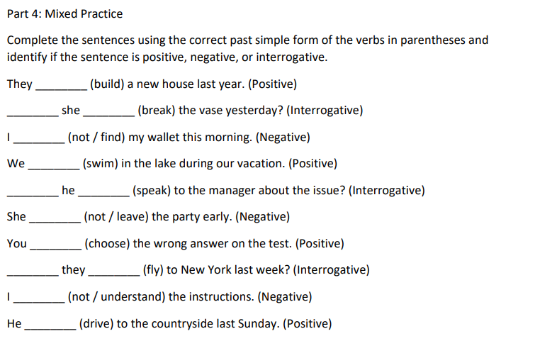

They built a new house last year.

Did she break the vase yesterday?

I did not find my wallet this morning.

We swam in the lake during our vacation.

Did he speak to the manager about the issue?

She did not leave the party early.

You chose the wrong answer on the test.

Did they fly to New York last week?

I did not understand the instructions.

He drove to the countryside last Sunday.

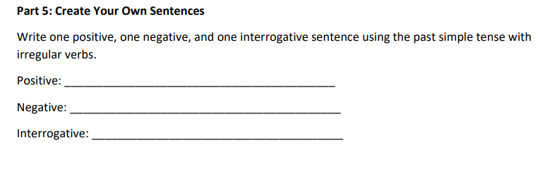

Positive: She sang beautifully at the concert.

Negative: They didn't break the window yesterday.

Interrogative: Did he drive to work this morning?

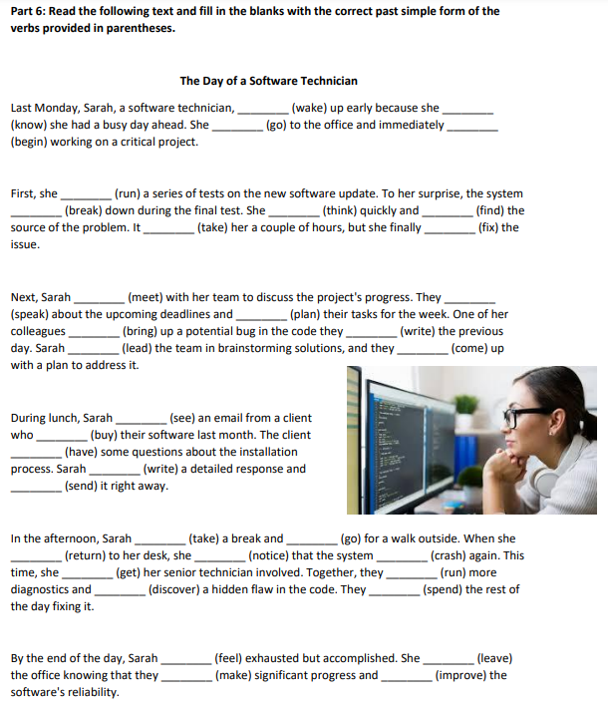

The Day of a Software Technician

Last Monday, Sarah, a software technician, woke up early because she knew she had a busy day ahead. She went to the office and immediately began working on a critical project.

First, she ran a series of tests on the new software update. To her surprise, the system broke down during the final test. She thought quickly and found the source of the problem. It took her a couple of hours, but she finally fixed the issue.

Next, Sarah met with her team to discuss the project's progress. They spoke about the upcoming deadlines and planned their tasks for the week. One of her colleagues brought up a potential bug in the code they had written the previous day. Sarah led the team in brainstorming solutions, and they came up with a plan to address it.

During lunch, Sarah saw an email from a client who had bought their software last month. The client had some questions about the installation process. Sarah wrote a detailed response and sent it right away.

In the afternoon, Sarah took a break and went for a walk outside. When she returned to her desk, she noticed that the system had crashed again. This time, she got her senior technician involved. Together, they ran more diagnostics and discovered a hidden flaw in the code. They spent the rest of the day fixing it.

By the end of the day, Sarah felt exhausted but accomplished. She left the office knowing that they had made significant progress and improved the situation for their clients.